Maximum marks for Assignment: _________6______ Assignment Declaration Date:____________
Assignment Submission Date (on or before):______________________________
Assignment assessment declaration Date by faculty (on or before):________________________
Question NO | Question Statement | Level of mapping and Number |  |  | Blooms Level | Marks
Question NO | Question Statement | CO | PO | PSO
Q1. | What is test automation? Scope of automation. | CO3 | PO1 |  | 1 | 2
Q2 | List and explain skills needed for automation | CO3 | PO1,PO2 |  | 2 | 4
Q3 | What are some of the challenges in automating the testing of GUI portions of an application? How do these compare with the automation of back- end testing | CO3 | PO2,PO3 |  | 4 | 6
Q4 | What are the selection criteria of automated testing tool | CO3 | PO1,PO2 |  | 2 | 4
Q5 | Design an architecture for automation | CO3 | PO1 |  | 3 | 4
Q.6 | Short note on Jmeter and JUnit | CO3 | PO2,PO3 |  | 3 | 4
Q.7 | List generic requirement for test tools | CO3 | PO4 |  | 3 | 4
Q.8 | What are the difference in testing automation in agile and waterfall model | CO3 | PO1,PO3 |  | 4 | 4
Q.9 | What is data Driven testing (DDT)? Explain data driven testing framework | CO3 | PO1,PO2 |  | 2 | 4
Q.10 | What challenges faced by the time of automation | CO3 | PO4,PO5,  PO11 |  | 2 | 6
Q.11 | Discuss the test Automation for XP/Agile model. | CO3 | PO3 |  | 2 | 4
Q.12 | Explain features of J unit software testing tool | CO3 | PO2,PO3 |  | 3 | 3
Q.13 | Explain different types of code coverage testing | CO3 | PO2,PO3 |  | 3 | 4
Blooms level no | Blooms Taxonomy terms
6 | 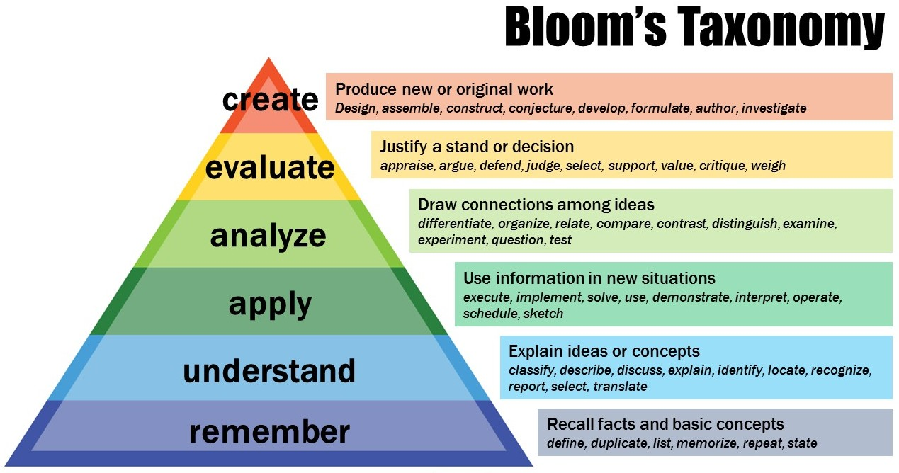
5
4
3
2
1

Subject In-charge HOD

